**PUBLIC AUCTION**

**SATURDAY September 16,2017**

**SALE STARTS AT 9:00 AM**

Located: Adams County 4-H Dining Hall

Monroe, IN 46772

**Furniture**

4-piece bedroom suite; 3-piece bedroom suite; Oak kitchen table with 6 chairs; Round kitchen table with 4 chairs; Drop leaf table with 2 leaves; Sofas; Swivel rockers; Cocktail tables; Berne Furniture wing back chairs; 2- Sleeper sofas; Marble top oval table; Sofa table; Coffee table; Slanted front desk; Sewing machine; End tables; Wood Rocking chairs; Floor lamps; Wash stand; Brass Lamps; Book Shelve; Desk; Table with 6 chairs; Buffet; TV stand; Sewing machine in cabinet; Patio table with 4 chairs; Globe; Chair; Ottoman; 4 oak Kitchen chairs; Lamps; Quilt Rack; Oak Shelves; Drop Front record cabinet; Nice 5 drawer oak jewelry chest; Poly Vinyl Patio table with 4 chairs; More Furniture coming

**Household/Collectibles**

12 place setting Rose China “Sweet Love” pattern; Big collection American Fostoria; Milk Jug Collection(Gallon and Half Gallon Bottles); Pewter plate collections; Corning ware; Baking Dishes; Tupperware; Crock pot; Corelle; Longaberger baskets; Pots; Pans; Silverware; Kitchen utensils; Cuisinart toaster oven; Cuisinart Coffee pot; Keurig Coffee maker; Bread maker; Electric mixer; Dishes; tv trays; Baskets; Records; Carnival glassware; Quilts; Comforters; Clothes Rack; Books; DVD’s; Cd’s; Proform & Waller 545S Elliptical; Stereo; Carpet Cleaner; Pictures; Decorations; 2 dehumidifiers; Microwave; Baseball Card Collection; Nascar Card Collection; 1979 Stroh NBA All-Stars Glasses(Detroit Pistons); More boxes still coming

**Tools**

Lawn chairs; Shovels; Rakes; Shelves; Bird Bath; Extension cords; Hedge Trimmers; Wooden outdoor chairs; Vinyl cabinet; Gas Grill; Tools; Post hole digger; Rolling Scaffold; Extension Ladder; 4’ folding table; Garden Hose; Chain Saw; shop vac;

Terms: Cash/Good Check Clerk: RJ Lautzenheiser

7 % sales tax Lunch stand: Summer’s Kitchen

**Ruth Ann Schmitt, Alfred & Elaine Plew, Judy Mehling, and Other Owner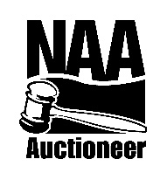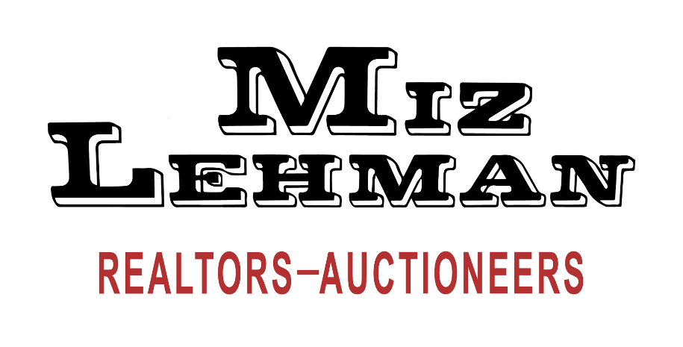s**

265 W Main St. Berne, IN 46711 *260-589-2903* [www.mizlehman.com/www.auctionzip.com](http://www.mizlehman.com/www.auctionzip.com)

**AC63001588**

**CHRIS YODER #AU01030238 BART LEHMAN #AU8800606**

**JASON BLUHM #AU08900171 PHIL WULLIMAN #AU01001374**