KATIE CAFFEE BENEFIT AUCTION

**Saturday, September 23, 2023**

**Doors open at 4:30pm Event starts 5:00pm**

**Location: SPARE TIME LANES**

**1306 US HWY 27. Berne, IN 46711**

**SILENT AUCTION, LIVE AUCTION, FOOD & DRINKS**

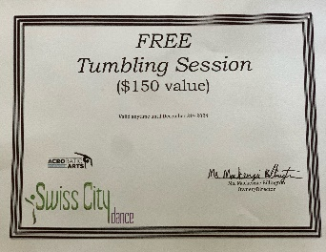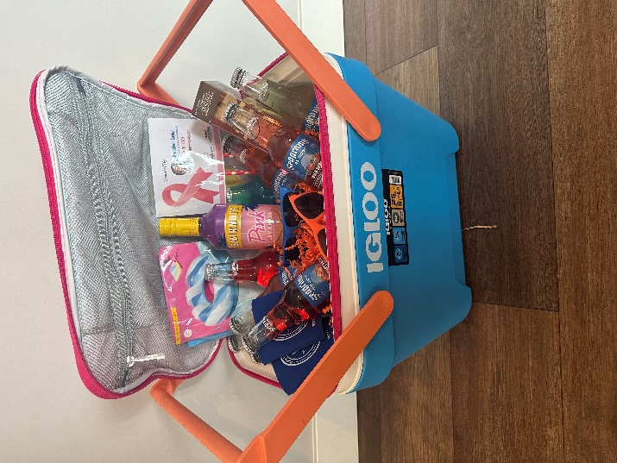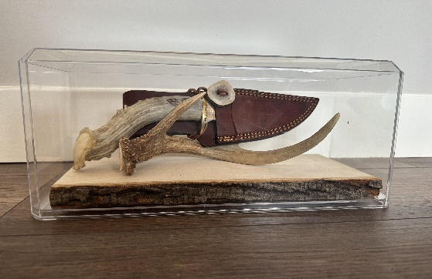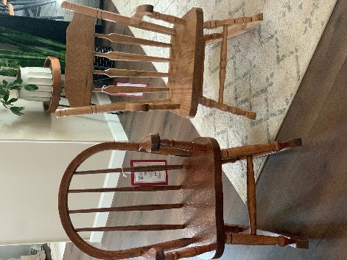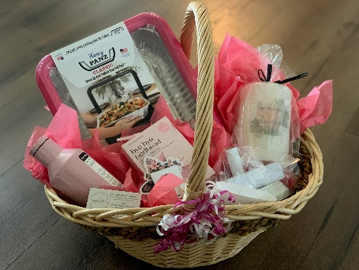**Auction Items: Meal to feed 12-15 people, Children’s Books, Gift Bags, Basket of PINK goodies, 4 Colts tickets with parking pass to 11/26 game, Quarter Angus beef, Baked Goods, Yeti Cooler with Yeti water bottle, Salon product bag, 4- One Day Pool Pass, Fulton & Main Gift card, Berne Gift Card Package, Express Oil Change, Basket with t-shirt, gift cards, hat, mug and vase with flowers, 2 smoked pork butts with pumpkin rolls, Lantern with candle, 2 kids rocking chairs from BernHaus Furniture, 2 Chicago Bears football tickets with parking pass & Coach Walters autograph, Load of stone plus delivery from Luginbill Excavating, East of Chicago gift card, golf basket, Fire Pit & Metal Sign, Gypsy Soul gift card, Spare Time Lanes Gift card, Bird Feeder, South Adams All Sports Pass with ADIDAS sweatshirt, 3 wellness center gym memberships, blankets, BBQ basket, Power Washing, Limo Rental for 5 hours, Lululemon belt bag and Stanley cup, Wine Basket, Nora Grey tote bag, 2 Komets tickets for 3/20, Blackstone with Blackstone basket, Paddle Board, Vera Bradley items, Fragrance set, Lane 201 Gift card, Cooler of Beef, Gersh $99 Gift card, Best One $250 Gift Card, Tumbling Session from Swiss City Dance, Bourbon Gift Set, Alcohol Wagon and MUCH MORE!!!**

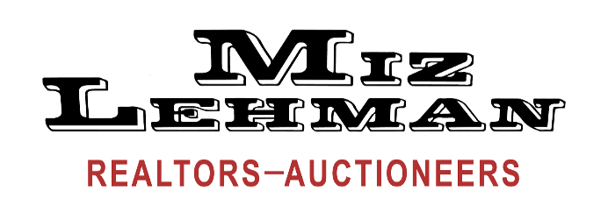

265 W Main St. Berne, IN 46711 *260-589-2903* www.mizlehman.com www.auctionzip.com

**AC63001588**

**CHRIS YODER #AU01030238 BART LEHMAN #AU8800606**

**JASON BLUHM #AU08900171 PHIL WULLIMAN #AU01001374**