**PUBLIC AUCTION**

**Saturday October 14, 2023**

**Starts at 9:00AM**

**Location:** Lehman Park Pavillion: 212 Park Ave Street Berne, In 46711

**Furniture:**

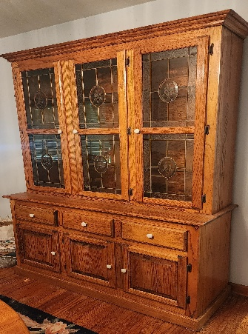3-piece Oak Bedroom Suite (High Head Board, End Table, Dresser with mirror); Oval Oak Kitchen Table with 10 Chairs; Oak China Cabinet; Side Board; 3 Piece Full size 4 post bedroom suite; Multiple Couches; Curio Cabinet; End Tables; Lazy Boy; Side Table; Table with 4 Chairs; Dresser; Multiple Bookshelves; Ladder Shelf; Lazy Boy; Rocking Chair; L-Shaped Desk; Wooden Office Chair; White Bench; Lamps; Cedar Chest; Card Table and Chairs; Upholstered Chairs;

**Household:**

Our Swiss Pantry; Coca-Cola Collections (Trays, Napkin Dispenser, Bottles, Cans, Clock, Tins); Rugs; Enterprise Sausage Stuffer; Glassware; Coffee Pot; Christmas; Stereo; Wall Hangings; Wall Décor; Lamps; Pictures; Double Sink; Glasses; Pans; Skillets; Corningware; Tupperware; Dr. Seuss Books; Cast Iron Skillet; Kitchen Utensils; Bedding; Silverware; Games; Longaberger; Christmas Tree; Christmas Décor; China; Pampered Chief; Power Rider; 5 lb. tabletop scales; 6ft folding tables

**Tools-Outdoor:**

Ladder 4 Ft; Toro Snowblower; Lawn Boy Push Mower; Polywood Bench; 8ft step ladder; Garden Tools; Planet JR. No 2 Edger; Drill Bits; Wrenches; Metal Work Bench; Outdoor Light Up Nativity Set; Wheel Barrow; Weed Trimmer; Bike; B&D Sander; 28ft Aluminum Extension Ladder; Lots more still coming

Terms: Cash, Check, Credit Card with fee -7% Sales Tax - Preview Friday Oct 13th 4-6 pm

**Stewart and Others Owners**

